**Task no 8**



**Microprocessor Based System Design**

**Spring 2022**

**Submitted by**

**Name Registration no**

**Muhammad Ali 19pwse1801**

**Submitted to: Dr Bilal Habib**

**Data: 27/6/2022**

**Department of Computer System Engineering**

**Code: -**

#include <reg51.h> #include <stdio.h> int wave_sts=0;

void Delay(unsigned int x) { unsigned int i;

for(i=0;i<x;i++);

}

void external_interupt_initialize()

{

IE=0x81; //external interupt 0 is enabled

IT0=1; // Select Ext. interrupt0 on falling edge }

void ext(void) interrupt 0 //ISR for external interrupt 0;

{

wave_sts++;

if(wave_sts==4)

{

wave_sts=0;

}

}

void main(void)

{

external_interupt_initialize();

while(1)

{

if(wave_sts==0) {

//sine wave

unsigned int

sine[]={128,156,192,226,238,255,238,226,192,128,64,32,6,4,0,16,32,64}; int i;

for(i=0;i<18;i++) {

P1=sine[i];

Delay(400);

}

}

else if(wave_sts==1) //saw tooth

{

P1=0; P1 =

0xFF; while(P1

!= 0x00)

{

P1--;

Delay(40); //Delay

}

}

else if(wave_sts==2) //Square Wave

|  |  |  |
| --- | --- | --- |
| {  P1 = 0x00;  P1 = 0xFF;  Delay(4400); |  | //Delay |
| P1 = 0x00;  Delay(4400);  } |  | //Delay |

else //triangular wave

{

P1 = 0x00; while(P1 != 0xFF) {

P1++;

Delay(45); //Delay }

while(P1 != 0x00)

{

P1--;

Delay(45); //Delay

}

}

}

}

**Schematic:**

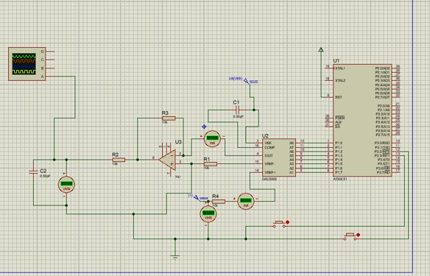

**Output:**

**Sine Wave:**

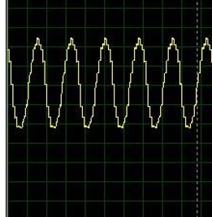

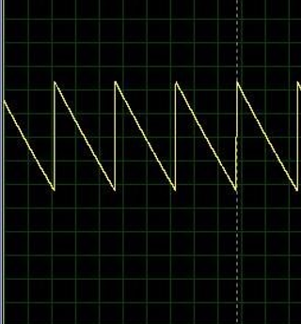

**Square Wave:**

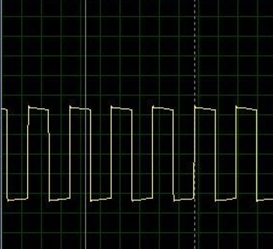

**Triangular Wave:**

